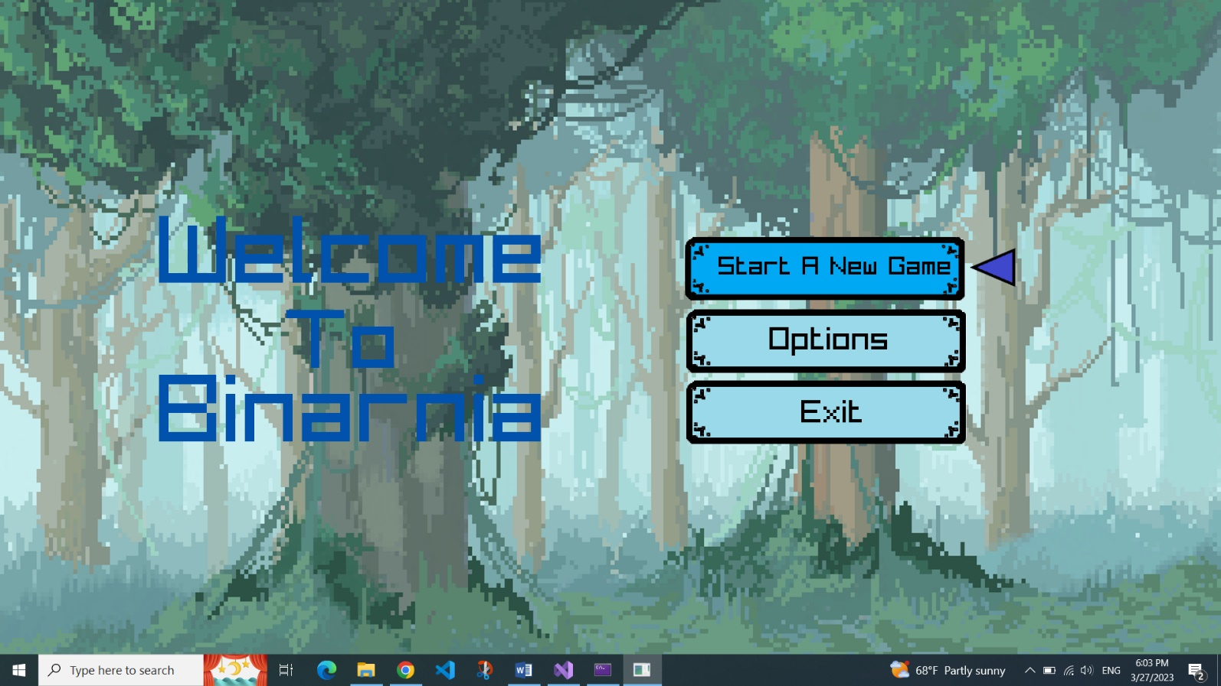**“Binarnia”**

**Test plan**

**Table of Contents**

**1.** **Introduction** 3

**2.** **Entry and Exit requirements** 3

**3.** **Project goals** 4

**4.** **Tasks** 4

**5.** **Testing** 5

**6.** **Testing process** 5

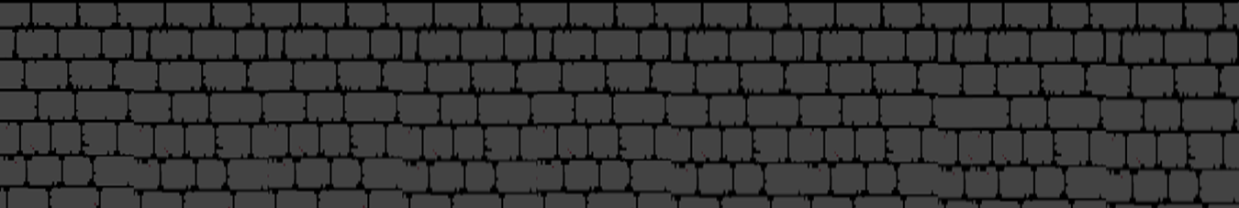

1. **Introduction**

**Our game "Binarnia" is a single player game where you help defeat the monsters in the forest by solving math problems and thus improving your math skills.**

1. **Entry and Exit requirements**



**Entry**

* **Access to the game is provided.**
* **The first tests begin.**

**Exit**

* **Most of the tests are successful.**
* **There are no errors preventing the program from working.**

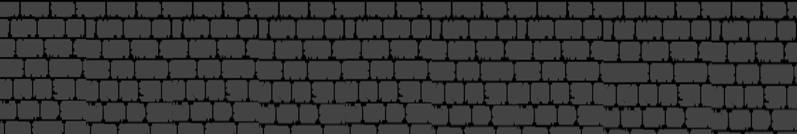

1. **Project goals**



**We aimed to organize ourselves well as a team and create a working program that people could use as a form of entertainment that also helps improving their thinking.**

1. **Tasks**





**The tasks that must be done to ensure our success are:**

* **To test the most important elements.**
* **Create multiple test cases.**
* **To prepare test and bug documentation.**

1. **Testing**



**Manual testing**

* **Menu options.**
* **Checking that error messages are displayed.**
* **Checking that the correct values are accepted by the code.**
* **Function testing.**

1. **Testing Process**



**Test results**

* **Excel table**
* **Test plan**

**Resources**

* **Excel for test management.**
* **Word for Test plan.**
* **GitHub for reporting issues.**